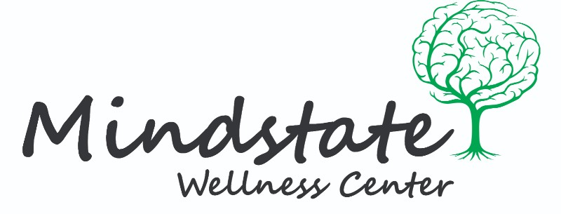
Resource and Referral List

Psychiatrist
Dr. Adnan Durrani
Lorton, VA 22079
durraam1980@gmail.com
(202) 315-8210

Licensed Professional Counselor
Ashley Mitchell, LPC
Guided Reflections
Burke, VA 22015
(703) 429-2459

Danijela Nardelli, LPC
BiofeedbackWorks
Herndon, VA 20170
(703) 689-0449

Medical Social Worker
Phillip Pope, MSW, LCSW
INOVA Fairfax Hospital
3300 Gallows Rd.
Falls Church, VA 22042
(703) 776-4001

Low-Cost Counseling
Catholic Charities Diocese of Arlington
3251 Old Lee Highway, Suite 402
Fairfax, VA 22030
(703) 447-9402
(Pro-bono services or pay on a sliding scale)
(Accepts Medicare and Medicaid)

Merrifield Center
8221 Willow Oaks Corporate Dr
Fairfax, VA 22031
(703) 383-8500
(Pay on a sliding scale)
(Accepts Medicaid and Medicare)

Open Path
https://openpathcollective.org/city/fairfax/

Local Support Groups
Al-Anon of Northern Virginia
www.alanonva.com

Alcoholics Anonymous
www.aavirginia.org/meetings

American Society for Suicide Prevention
https://afsp.org/our-work/chapters/

Depression and Bipolar Support Alliance of Northern Virginia
http://dbsanova.org/

Dual Recovery Anonymous
http://draonline.org/meetings_dra/usa/virginia.html

NAMI-Northern Virginia
www.NAMI-NorthernVirginia.org

Narcotics Anonymous
www.cprna.org/find-a-meeting/meeting-list/

Suicide Support Groups
www.suicide.org/support-groups/virginia-suicide-support-groups.html

Inpatient Care
Inova Psychiatric Assessment Center
8221 Willow Oaks Corporate Drive
Suite 4-420
Fairfax, VA 22031
(571) 623-3500

Sandstone Care – Virginia
11415 Isaac Newton Square South
Reston, VA 20190
(571) 200-7334

Intensive Outpatient Care/ Day Treatment
Sandstone Care – Virginia
11415 Isaac Newton Square South
Reston, VA 20190
(571) 200-7334

Encore Outpatient Services
4600 Fairfax Dr UNIT 906
Arlington, VA 22203
(703) 686-5755

Emergency Mental Health Services
CSB Mental Health Emergency Services and Mobile Crisis Unit
8221 Willow Oaks Corporate Drive
Fairfax, VA 22031
(703) 573-5679

Children’s Regional Crisis Response (24-hour rapid response for youth)
1(844) 627-4747

Emergency Substance Use Disorder Services
Fairfax Detox Center
4213 Walney Road
Chantilly, VA 20151
(703) 502-7000

Children’s Regional Crisis Response (24-hour rapid response for youth)
1(844) 627-4747
Emergency Hotlines
Domestic & Sexual Violence Hotline
(703) 360-7273

Suicide Prevention Hotline
1(800) 273-8255
Text “connect” to 855-11

Veterans Crisis Line
1(800) 273-8255, and press 1
Text 838-255
Chat online at www.mentalhealth.va.gov/suicide_prevention/veterans-crisis-line.asp

